**METAMORPHOSING INTO AN ADVANCED MAPPER IN TWO WEEKS BY THE HELP OF THE MICRO GRANT 2018**.

Once upon a time, when I was young I so much loved to be challenged. I so much love to see my strength and weakness between me and others. So that I can know my stand and in most cases I will always be among the best three, although I may not win but I will believe in myself to be very successful someday.

When I entered school, I was introduced to a team called UniqueMappersTeam ad I joined the team and saw that what they were doing was not very relevant to my field of study and it requires data bundle and laptop mostly to do what they called mapping with OSM. So I created an OSM account and became an inactive member for almost a year.

In addition, the inactive member was brought very close and was empowered by HOT MICRO GRANT 2018, so the team provided necessary devices needed to make an active member and put the whole team leaders into a mapping battle, so we had a two weeks mapathon that requires each contestant to get a minimum number of building before you can qualify to the next stage, so my competition spirit was ignited and the battle began and I was the list in the Leadership board and I became angry and beat my hand in at my chest and started mapping and I moved from 7th position to 5th position and from 5th to 3rd and finally at the end from 3rd to 2nd position . I was very happy because I don’t accept defeat.

In conclusion, all thanks to HOT community for the MICRO GRANT that made me an advanced mapper. They have really done well by making me to contribute to humanity and also to the HOT DIRECTOR PETE MASTERS, AMALIE, NATHALIE AND OTHERS; I am saying a big thanks to you.

THE END.

Written by IKEOGU EMMANUEL CHIDERA, a student of the University of Port Harcourt, computer science and a developer, a technical director UniqueMappersTeam.

EMAIL : [ikeogu322@gmail.com](mailto:ikeogu322@gmail.com)

Facebook: [Emmanuel.chidera399@facebook.com](mailto:Emmanuel.chidera399@facebook.com)

Tweeter: @Emmanue49593774

GIthub: <https://github.com/ikeogu>

**My progressive images from 7th to 5th**

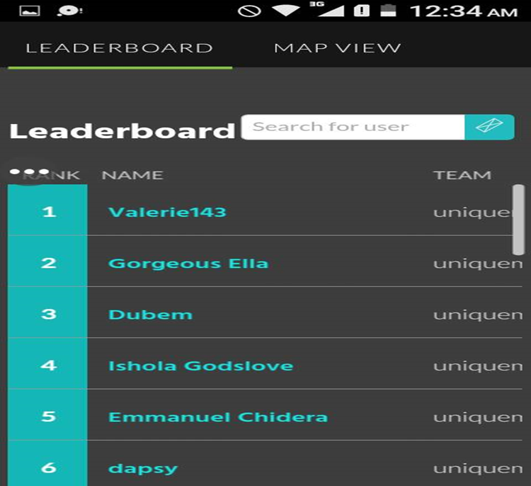

**From 5th to 3rd position**

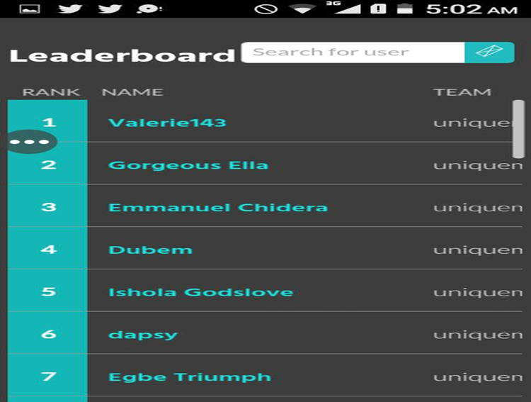

**From 3rd position to 2nd position**

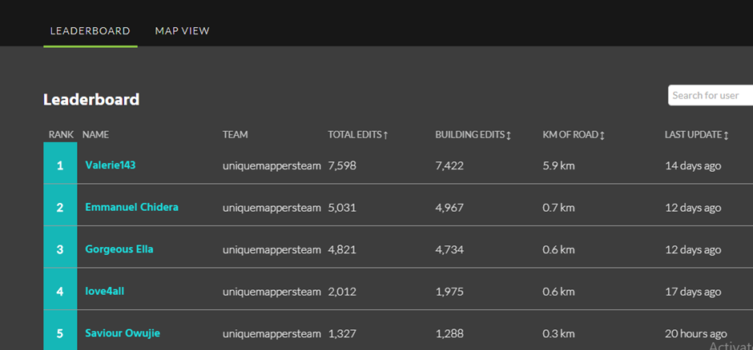

**How did I contribute to OSM with HOT MICRO GRANT?**

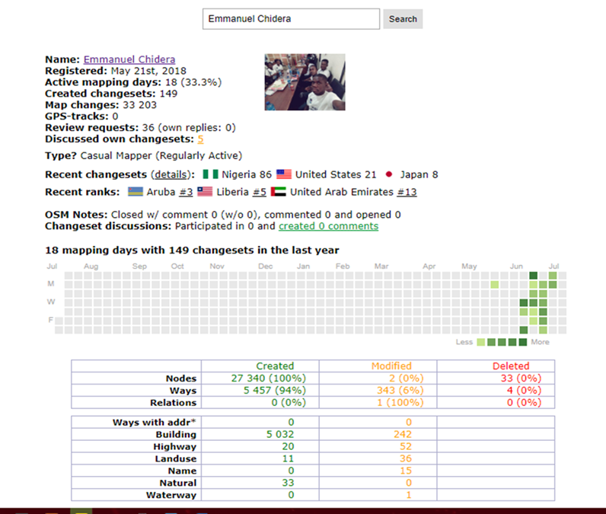

**LET’S SEE THIS EMMANUEL CHIERA**

